**Casual Jobs Database v.1**

Client Acceptance & Feedback Form





**Final Project Handover**

To:

Clement Sudhakar Swarnappa  
*Senior Academic Staff Member*

School of Information Technology  
DDI: +64 4 830 3130  
Email: clement.sudhakar@weltec.ac.nz  
URL: www.weltec.ac.nz  
Post : Private Bag 39803, Lower Hutt 5045  
Wellington, New Zealand

Project Team:

Supun Chandra Malimage – Project Manager

Kalaivani Ilango – Team Member

Ruban Ravi Sebastian – Team Member

Table of Contents

**Casual Jobs Database v.1** **Error! Bookmark not defined.**

**Client Acceptance & Feedback Form** 4

Task description: 4

Sitemap: 4

Client feedback on Sitemap: 5

Questionnaires: 5

Employer questionnaires: 5

Job Seeker questionnaires: 8

Client feedback on questionnaire: 9

Wireframe design: 10

Home 10

Employer: 11

Job seeker: 14

Admin Dashboard: 16

Casual Jobs V.1 homepage: 18

Register now: 19

Login: 20

Employer login: 20

Employer dashboard: 21

Job Seeker login: 24

Job Seeker dashboard: 24

About us: 27

Contact us: 27

Use case diagram: 28

Class diagram: 29

Activity diagram: 30

Entity Relationship Diagram: 31

Registration: 32

Edit/Delete User Information: 32

Login: 32

Employer Dashboard: 33

Add New Jobs: 33

Edit/Delete job: 34

Job Seeker Dashboard: 34

Add New Profile: 35

Edit/Delete Profile: 35

Job Matching: 36

View shortlisted Jobs: 36

Accept shortlisted Jobs: 36

Matched Profiles: 37

Shortlist: 37

Decline: 37

Logout: 38

Overall Client feedback: 38

# **Client Acceptance & Feedback Form**

|  |  |
| --- | --- |
| Milestone – Project Handover | |
| Project Name: Casual Jobs Database V.1 | Client Name: Clement Sudhakar Swarnappa |
| Project Start date: July 6th, 2020 | Project End date: October 9th, 2020 |
| Milestone: Database design approval | Finished date: September 28th, 2020 |
| **Introduction of Milestone:**   * Wireframe * Frontend * Database * Backend | |

## Task description:

Based on the Rapid Application Development methodology, we have got an approval for each and every milestone from the client. This document is a incorporation of other RAD approval form integrated together here

## Sitemap:

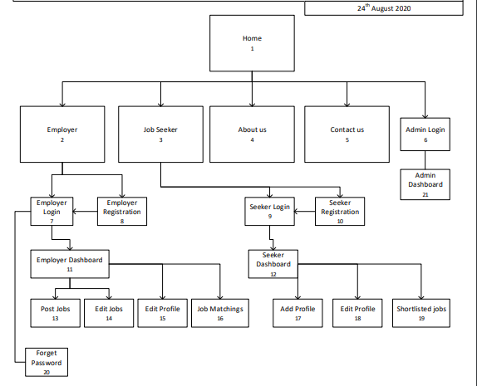

### Client feedback on Sitemap:

## Questionnaires:

Questionnaires has been prepared to match the requirements between Job seeker and Employer. This questionnaire would help to feed in both job seeker and employer details which supports the matching algorithm to select suitable candidate

Employer questionnaires:It is divided into 5 buckets, Job details, Job timing, Education, Experience, and other requirements.



Feedback: ………………………………………………………………………………………………………………………………………………………………………………………………………………………………………………………………………………………………………………………….



Feedback: ………………………………………………………………………………………………………………………………………………………………………………………………………………………………………………………………………………………………………………………….

Job Seeker questionnaires: It is divided into 5 buckets as Personal details, Availability, Education, Experience and other requirements.



Feedback: ………………………………………………………………………………………………………………………………………………………………………………………………………………………………………………………………………………………………………………………….



### Client feedback on questionnaire:

Feedback: ………………………………………………………………………………………………………………………………………………………………………………………………………………………………………………………………………………………………………………………….

## Wireframe design:

### Home

This page shows the brief introduction of this web application and the functionalities involved in this application. It describes about employer, job seeker, job stats, about the application, testimonials, contact us etc.,

We can get information about jobs like, job title, location, category, and type. Also, we can get an insight about number of jobs posted, matching jobs, number of companies posted the jobs and number of job seekers registered into this application.

**Client feedback:**

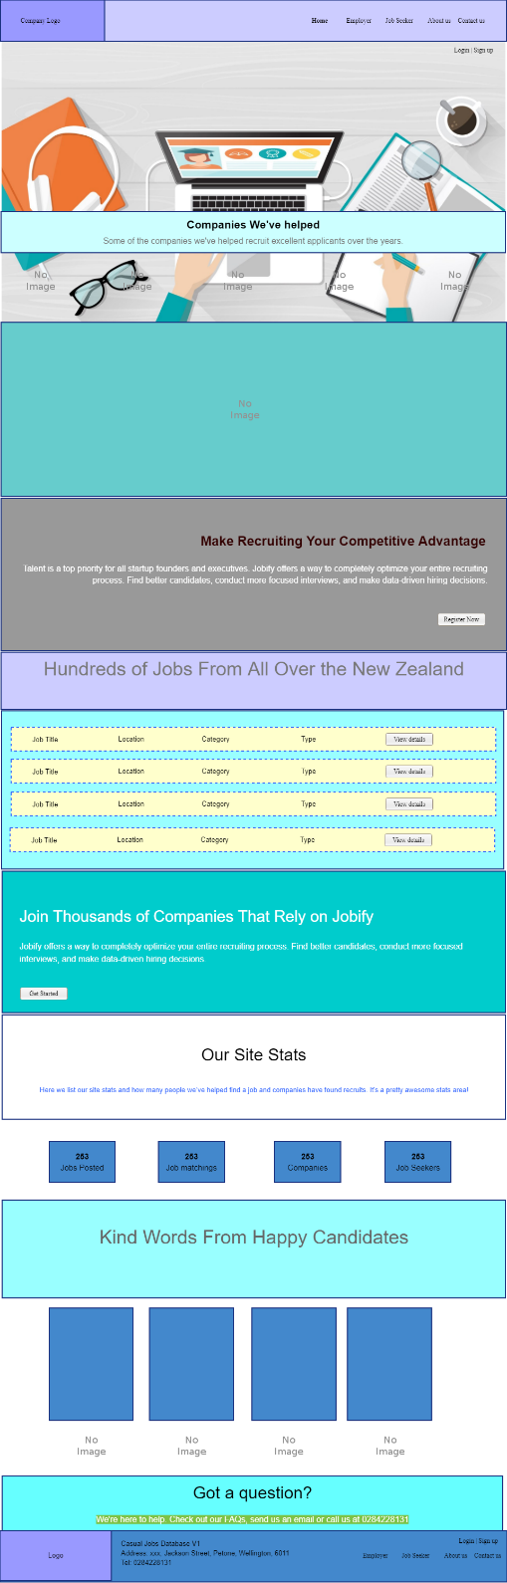

Feedback: ………………………………………………………………………………………………………………………………………………………………………………………………………………………………………………………………………………………………………………………….

Employer:If we click the employer tab, we will get the details of Employer login, Employer registration and Employer dashboard. Employer can directly login if they have already registered, else employer needs to register first to access the employer dashboard.

**Client feedback:**

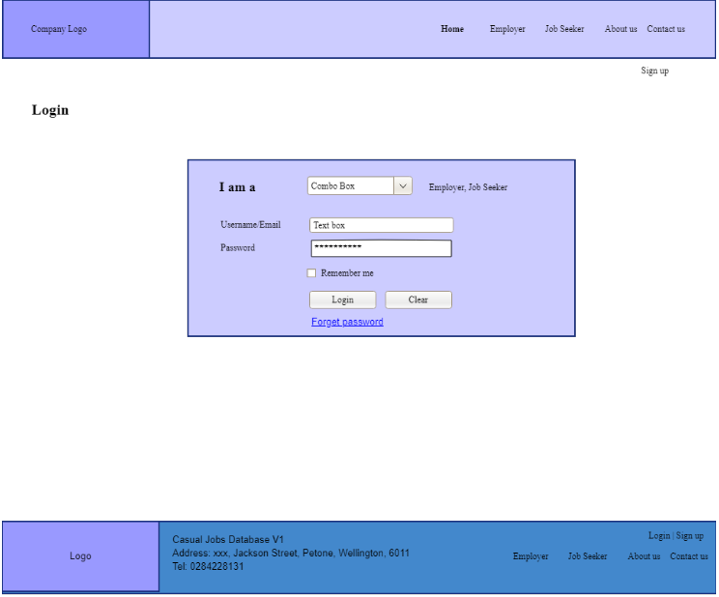

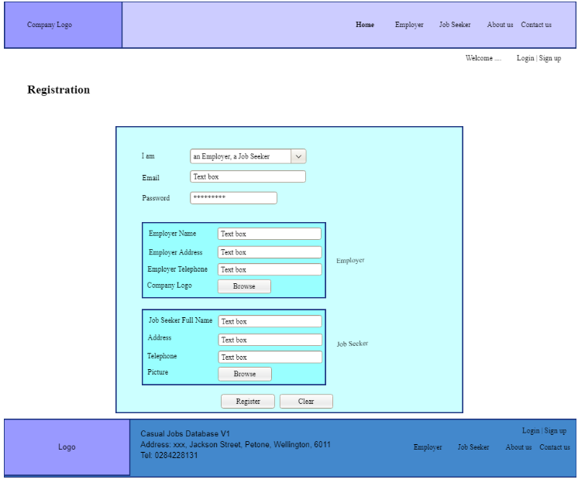

Feedback: ………………………………………………………………………………………………………………………………………………………………………………………………………………………………………………………………………………………………………………………….

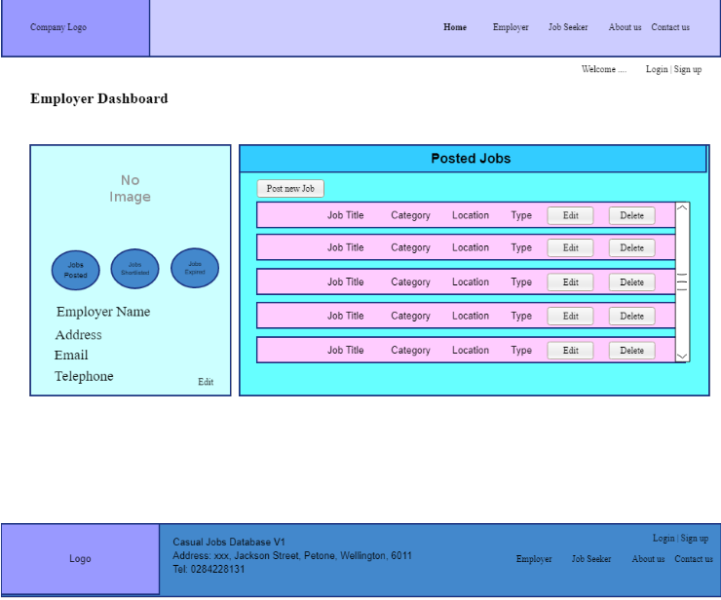

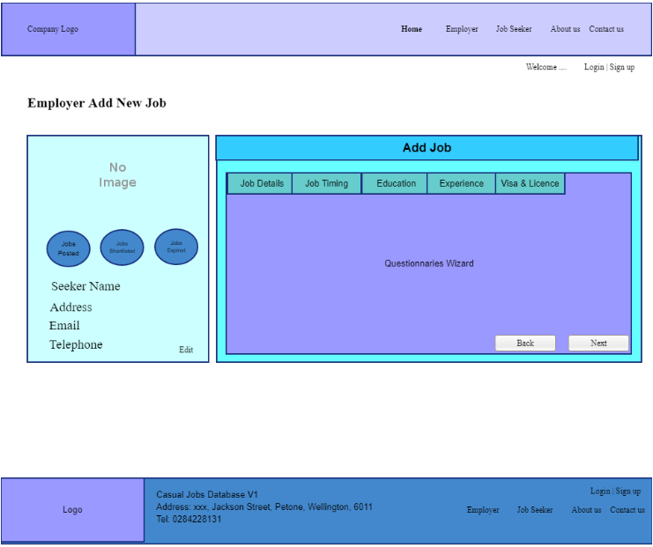

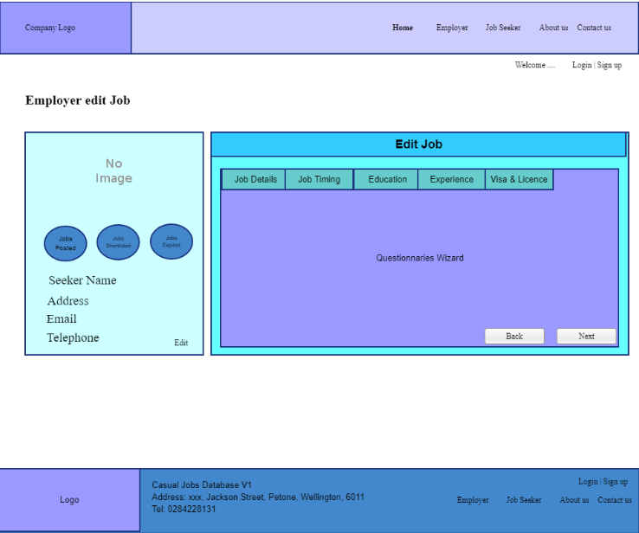

Feedback: ………………………………………………………………………………………………………………………………………………………………………………………………………………………………………………………………………………………………………………………….

**Job matching:** Under this page, employer could see the matching candidate profile based on the employer requirement.

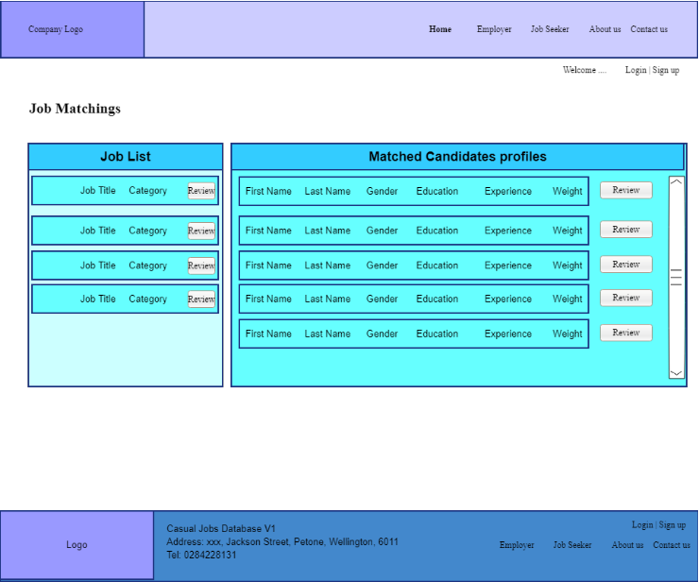

Feedback: ………………………………………………………………………………………………………………………………………………………………………………………………………………………………………………………………………………………………………………………….

Job seeker: If we click the Job seeker tab, it will take to the job seeker login page where the job seeker can login or register if they are a first-time user. Once registered, they can access the job seeker dashboard, number of jobs matching based on their education, experience and other requirements

**Client feedback:**

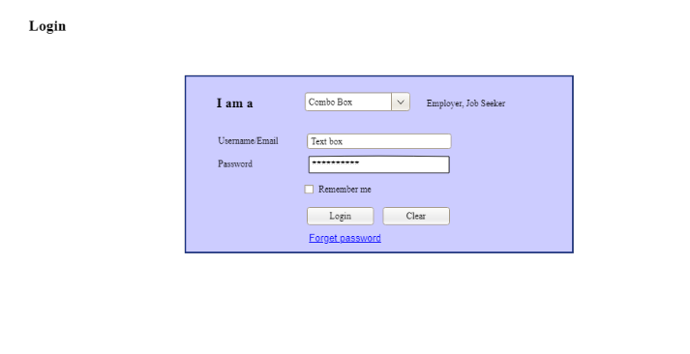

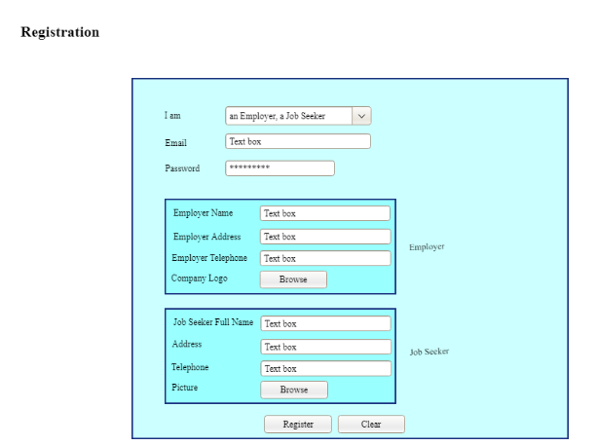

Feedback: ………………………………………………………………………………………………………………………………………………………………………………………………………………………………………………………………………………………………………………………….

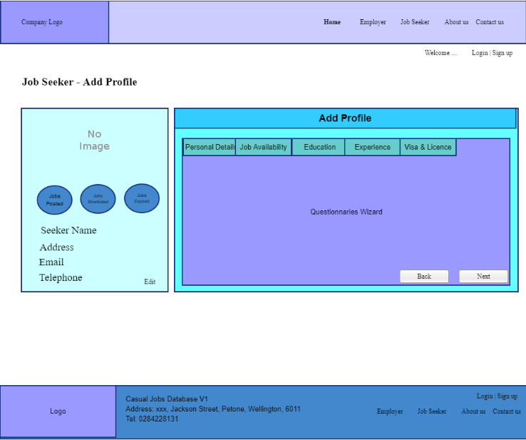

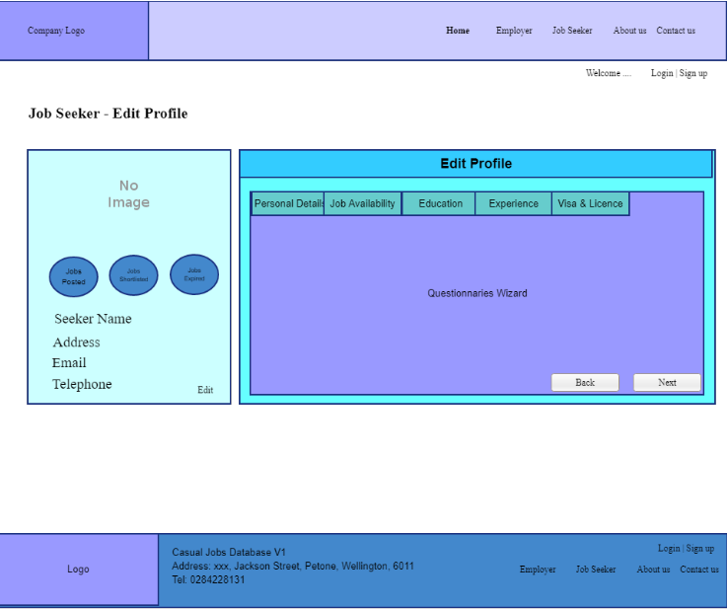

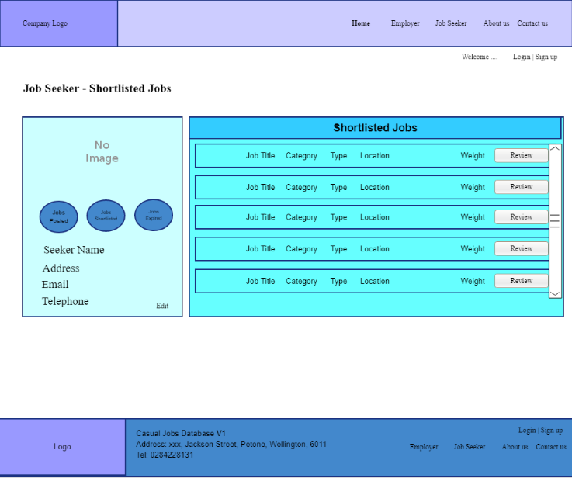

Feedback: ………………………………………………………………………………………………………………………………………………………………………………………………………………………………………………………………………………………………………………………….

### Admin Dashboard:

The client who owns this application manages the admin dashboard and update details about job categories, education levels, tertiary institute, specialized areas etc.,

**Client feedback:**

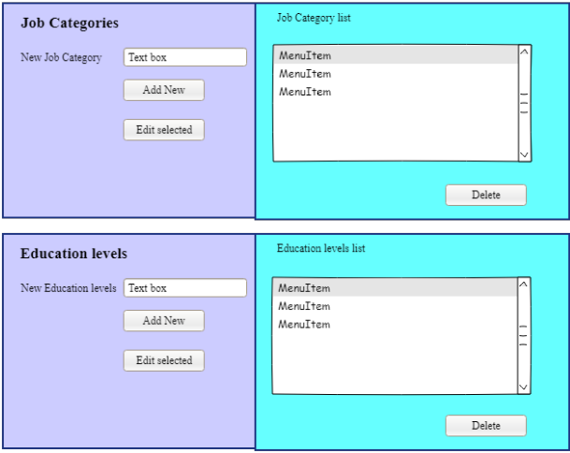

Feedback: ………………………………………………………………………………………………………………………………………………………………………………………………………………………………………………………………………………………………………………………….

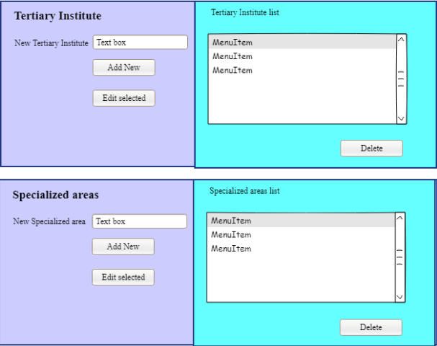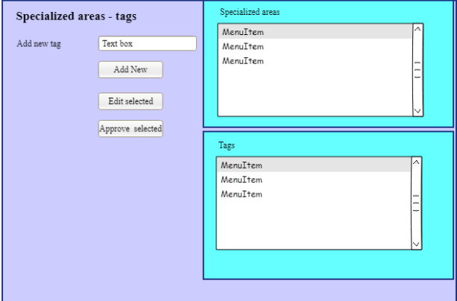

Feedback: ………………………………………………………………………………………………………………………………………………………………………………………………………………………………………………………………………………………………………………………….

## Casual Jobs V.1 homepage:

Below attached is the image of home page which has the features as follows.

* Registration for the first-time user
* Login for already registered user
* Navigate directly to employer or job seeker profile
* About and contact us options
* Details about Casual Jobs Database V.1 application with its benefits
* Ratings and reviews by users



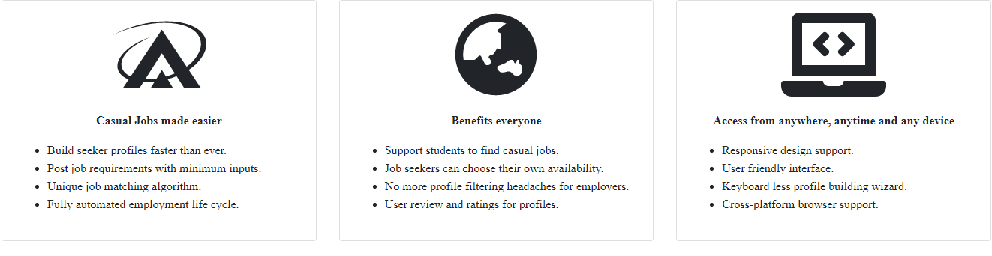

## Register now:

“Register now” option allows employer and job seeker to register themselves to access the casual jobs database

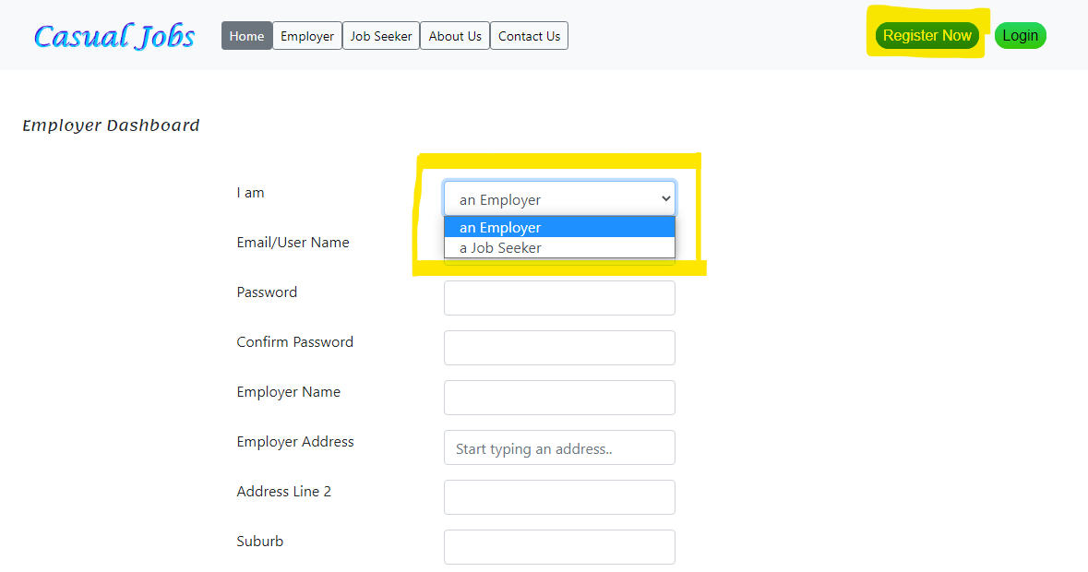

## Login:

Already registered employer or job seeker can directly access the login button by entering their credentials

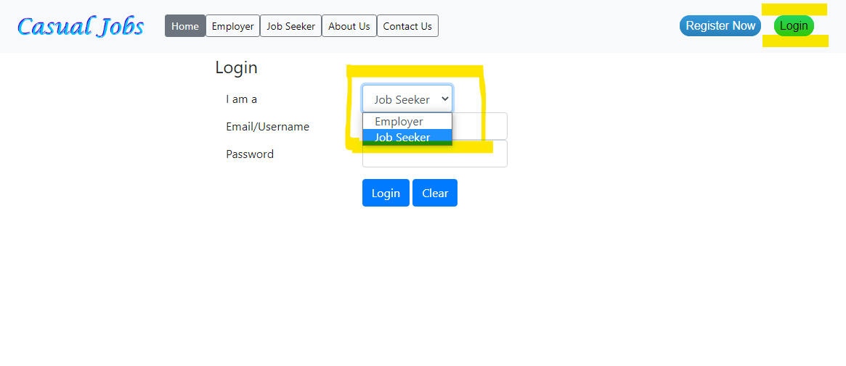

## Employer login:

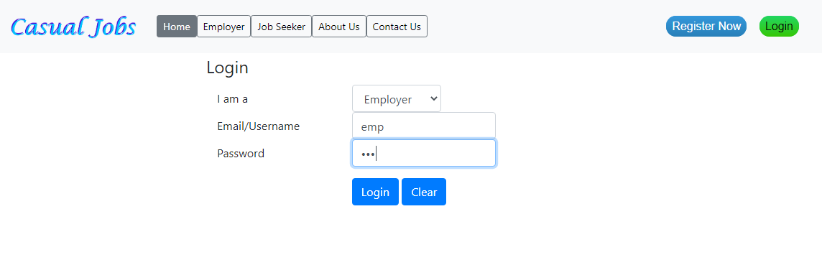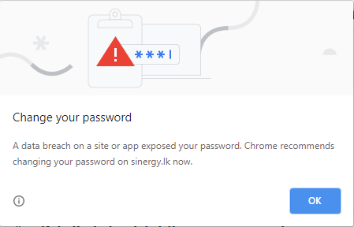

## Employer dashboard:

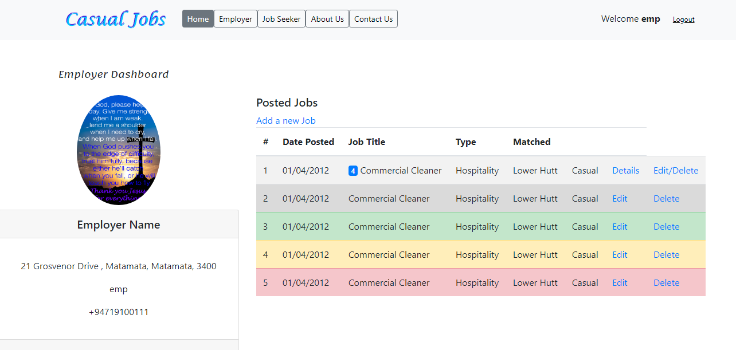

By clicking add new job in the employer dashboard, employer can add jobs, requirements to find the match

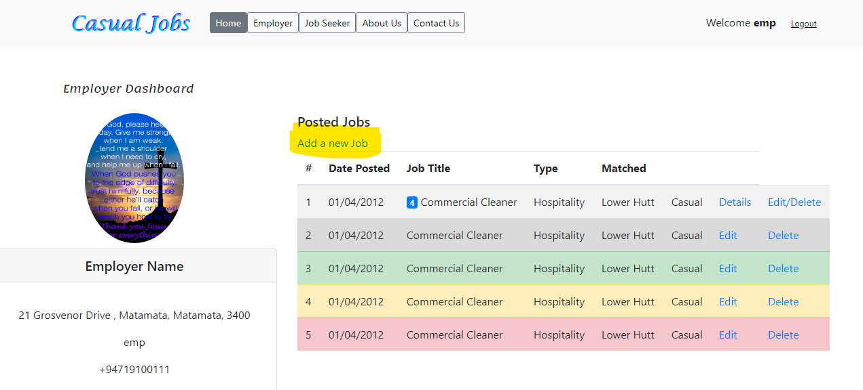

By entering the required details, employers can successfully complete adding jobs in the portal

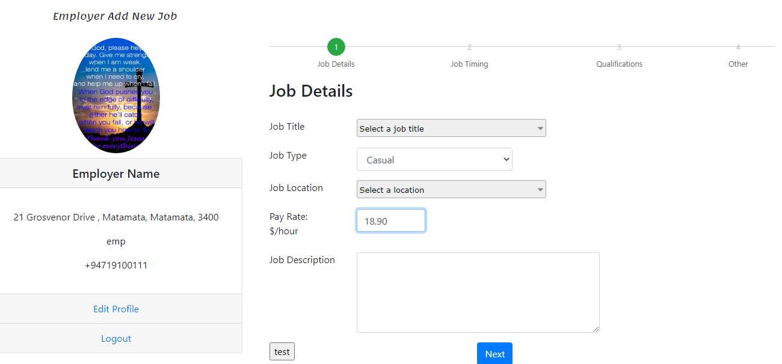

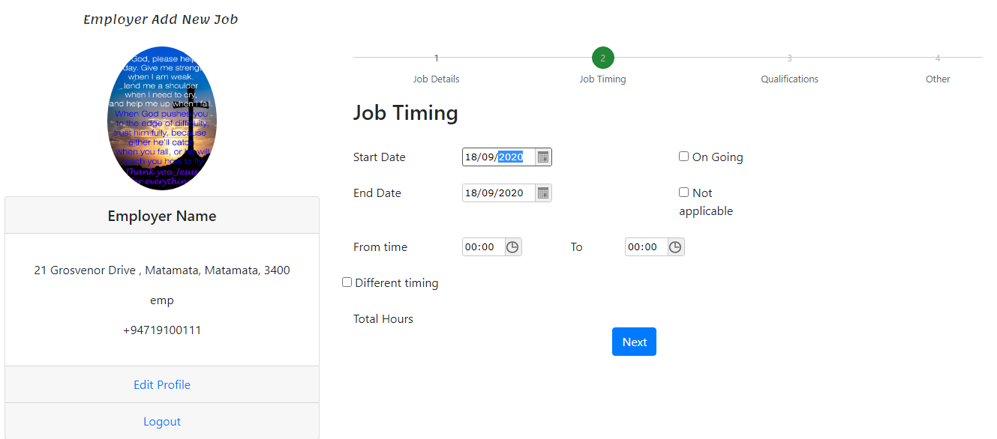

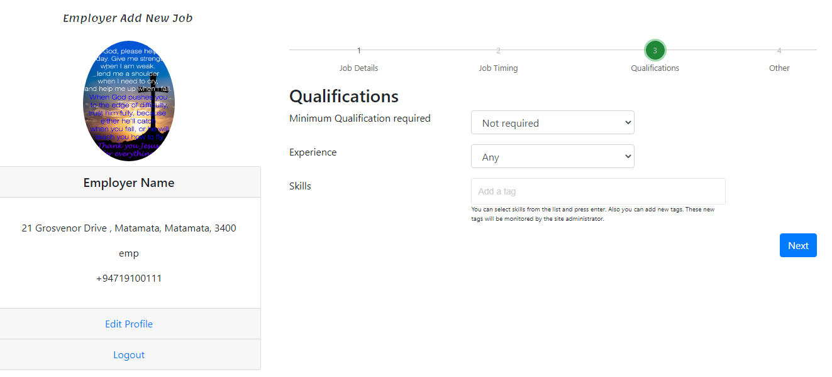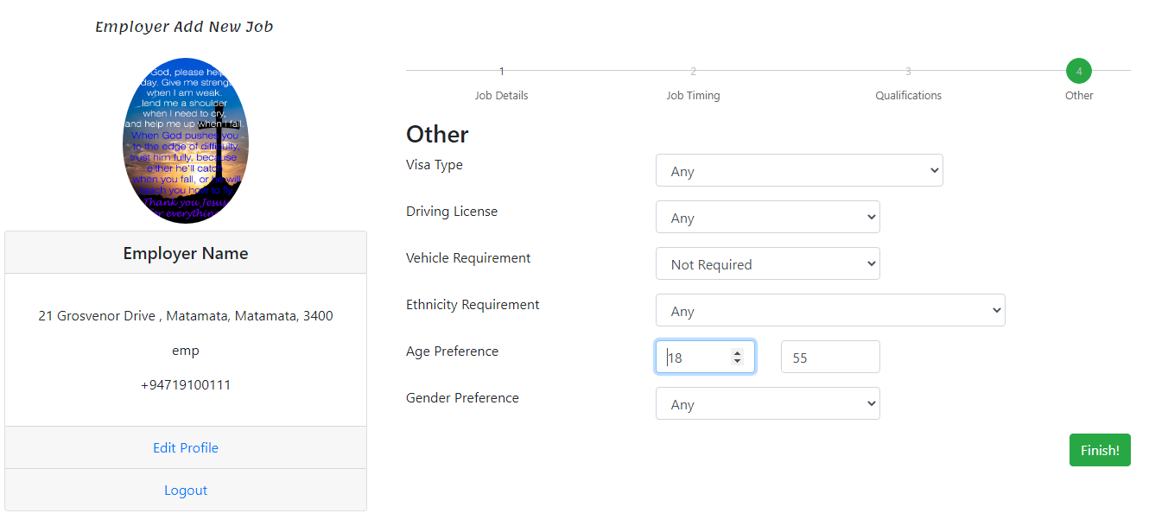

## Job Seeker login:

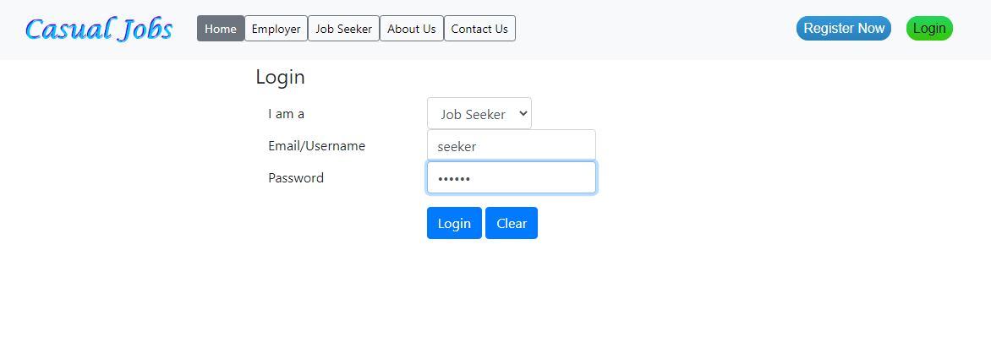

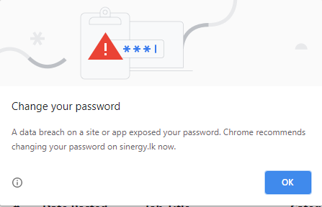

## Job Seeker dashboard:

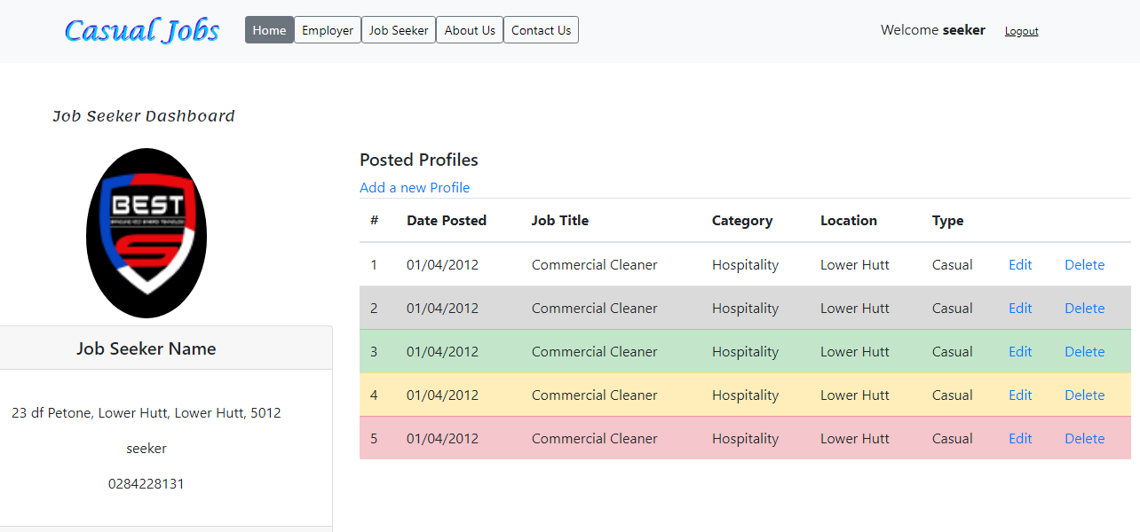

By clicking “Add a new profile” option, job seeker can add their profile based on their requirement.

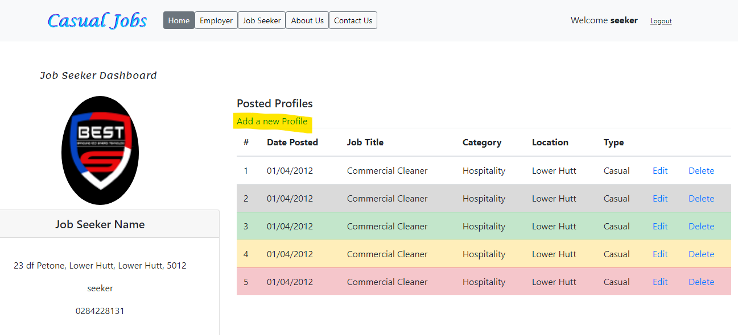

By entering the required details, Job seeker can successfully complete adding their profile in the portal

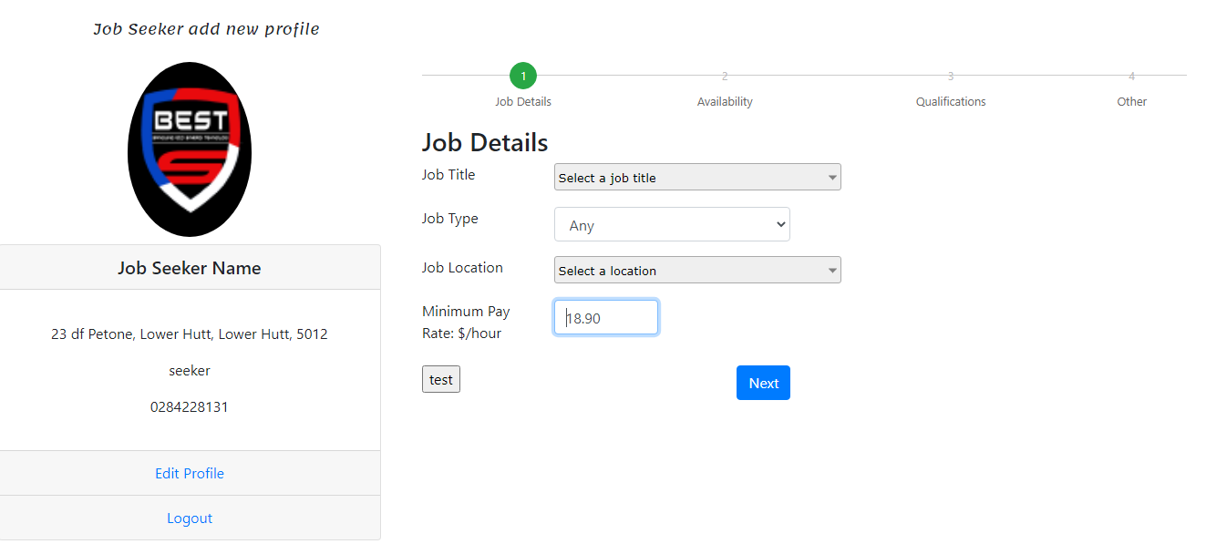

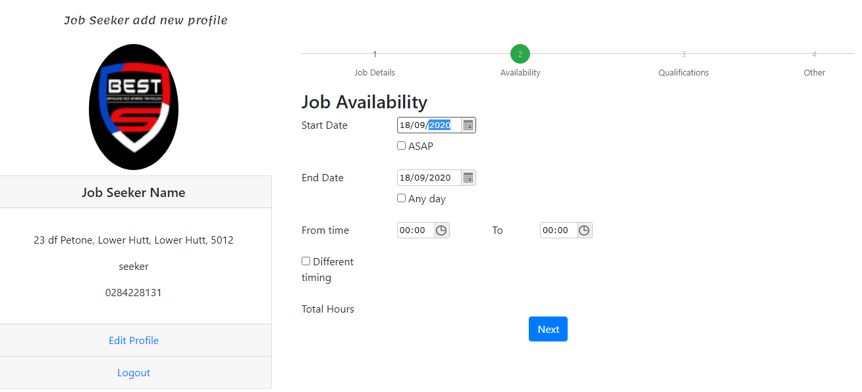

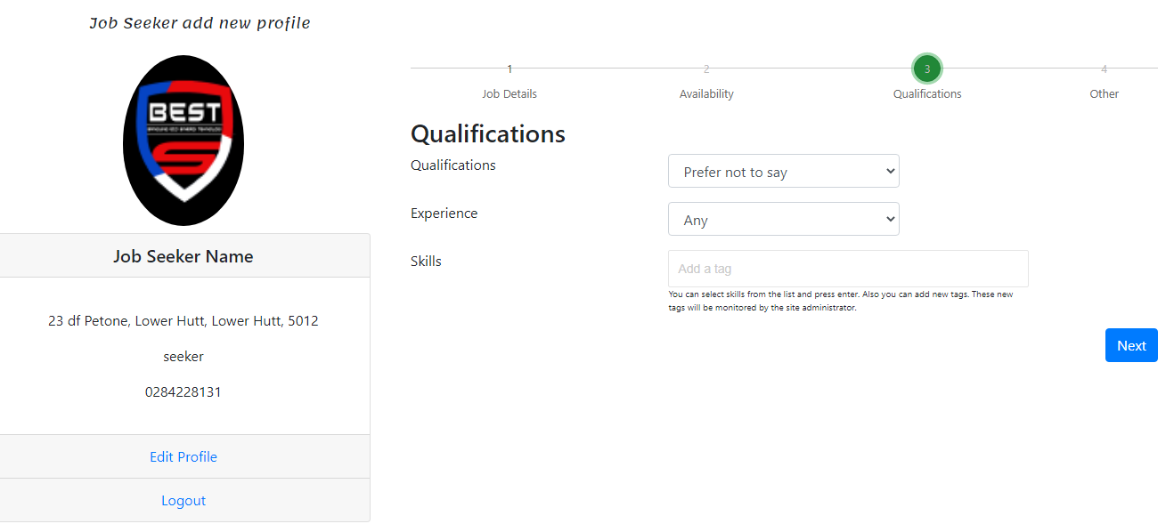

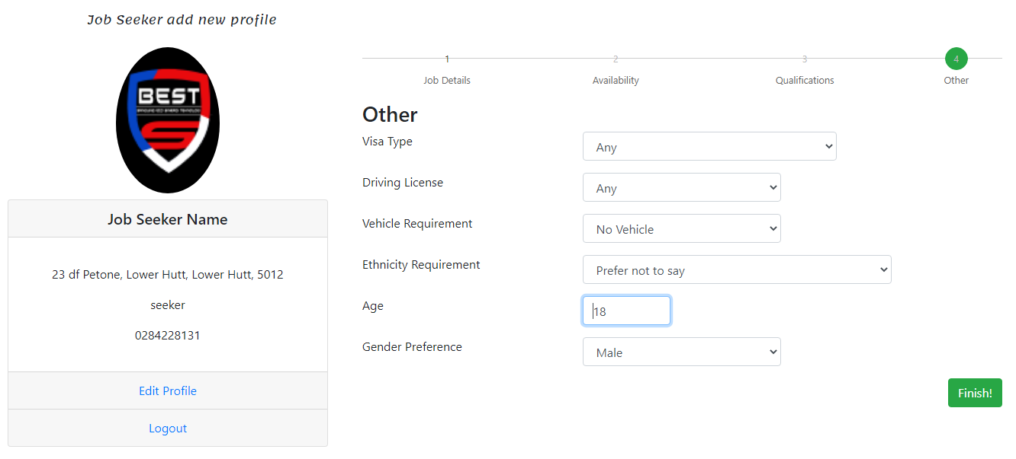

## About us:

This section provides the detailed description about who we are, the reason for creating this application, who will be benefited by using this application etc., 

## Contact us:

This section helps and provide accessibility to employer and job seeker to contact us for registering with Casual Jobs Database, login, careers, future opportunities etc.,



## Use case diagram:

Use case diagram represents the actor’s behaviour of the system. Figure 1 shows the high-level requirement of the system and explains the relationship between actors and the different use cases in which the whole system involved. The role of the actors in Casual Jobs Database V.1 is to interact with the system. List of actors in Casual Jobs Database V.1 are as follows:

* AC01 Employer
* AC02 Job Seeker
* AC03 Admin

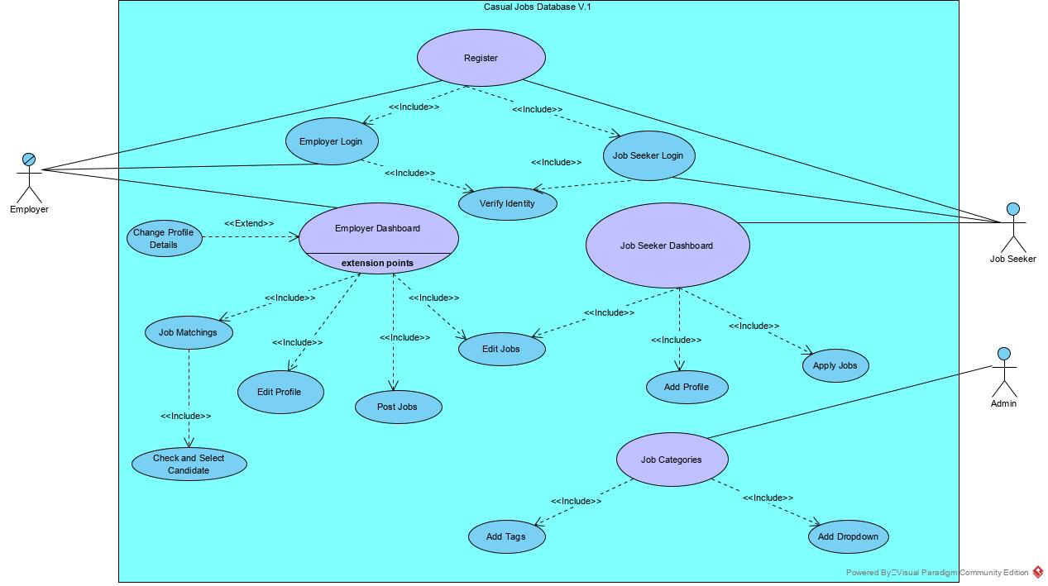

## Class diagram:

Class diagram represents the structure of the system by showing the system’s classes, their attributes, operations (or methods), and the relationship among objects.

The classes in a class diagram represent both the main elements, interactions in the application, and the classes to be programmed and the multiplicity represents the functions of the classes.

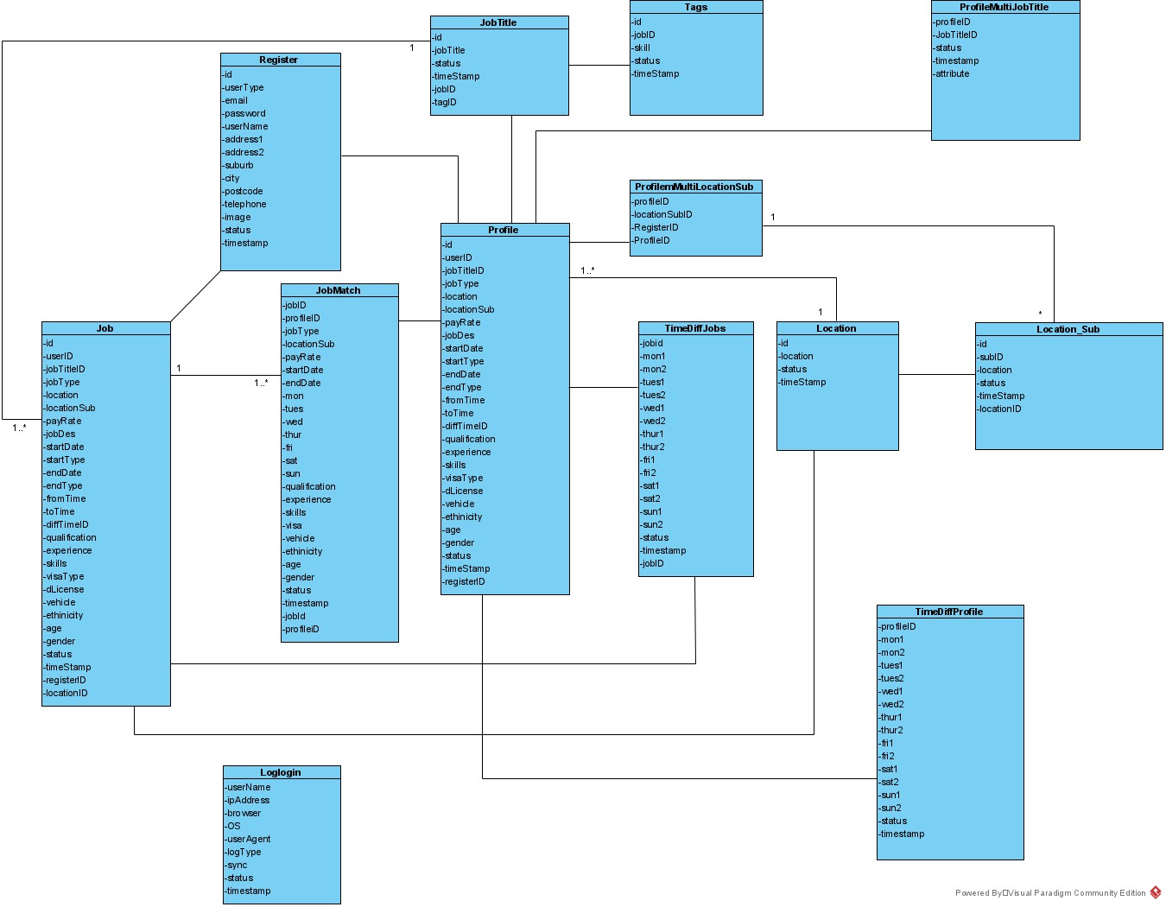

## Activity diagram:

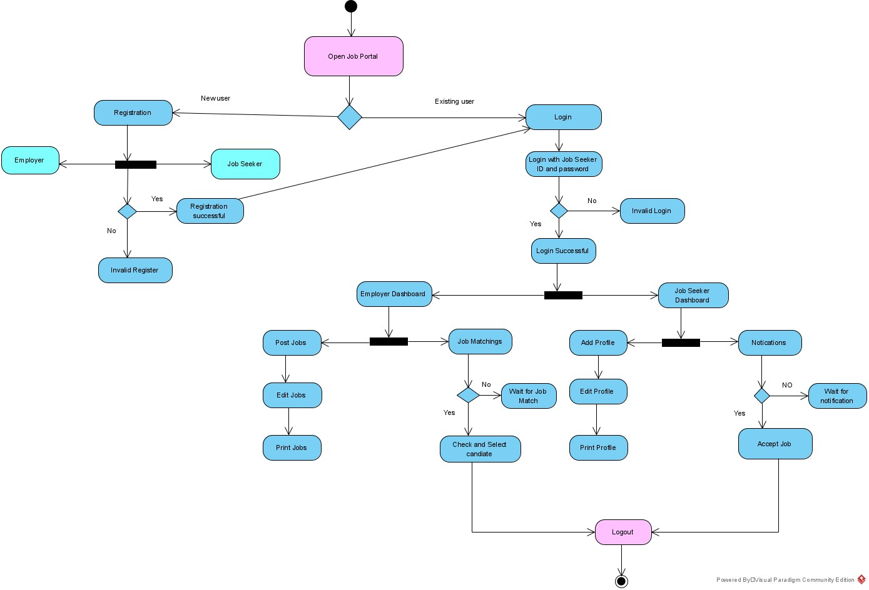Casual Jobs Database activity diagram explains about the series of actions performed by the employer and the job seeker. It represents the flow from one activity to another activity. Firstly, the employer register into the job portal. Once registration is completed, the employer logins into the portal for accessing the dashboard. Then the employer can edit and post the jobs. On the other hand, Job Seeker also registers into the portal. After registration, the Job Seeker logins into the portal for accessing the dashboard. And then, Job Seeker can add profile and edit it. As the employer and job seeker profile matches, the system sends the matched job seeker profile to the employer, the employer checks and select the candidate. And then the job seeker receives the notification for accepting the application.

## Entity Relationship Diagram:

ERD diagram helps to understand the tables and its relations in the database.

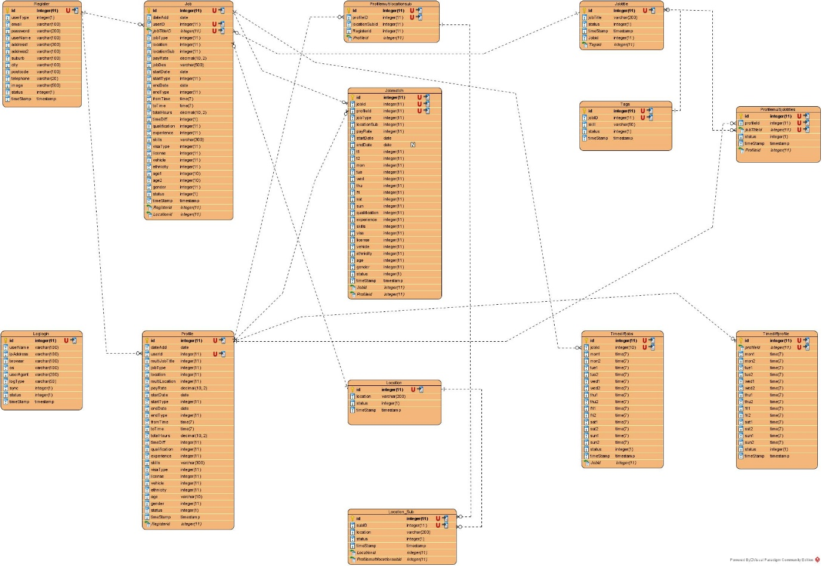

## Registration:

Registration is a first page where users’ will enter their details to start using the application and those details will be used to login into the application going forward. Registration details will be stored in the database at the backend, which would automatically detect the users whether they are an employer or job seeker when they login.

All the registration related files are located in:

www/register/ajaxupload.php – Profile Image upload.

www/register/data.php – Insert register data using this file.

Index.php – All the front-end code and connect to backend using ajax coding with jQuery.

## Edit/Delete User Information:

It is an important feature in all the application which consists users. Admin has the access to edit/delete users’ profiles which falls under performance or seems inappropriate. Admin holds complete authority and rights to terminate any users without prior notice based on their performance

All the user profile edit files contains as below:

www/editprofile/ajaxupload.php – Profile image change and remove.

www/editprofile/data.php – All the coding for updating user profiles.

www/editprofile/deleteprofile.php – This file contains delete user.

www/editprofile/index.php – This is the front-end file.

www/editprofile/loadData.php – This file calls at the load of index.php to retrieve user profile data.

## Login:

After registration process is done, login page allows the user to access the application and update the jobs or profile. Login page is designed in a way that it will automatically detect whether it is an employer or job seeker profile and take them to the respective dashboard. Employer and job seeker can login into the application by using right login credentials which is registered during the registration process.

www/login/check.php – This is the file verifies the login credentials entered.

www/login/index.css – Styles for the index.php file

www/login/index.php – front-end file

www/login/logLogin.php – This file track all the logins and logouts of users. It contains IP address, browser, date/time and device accessed.

## Employer Dashboard:

The employer dashboard database helps the employer to view their posted jobs, how many job seeker profiles matching with the jobs posted, shortlist the job seeker, decline the job seekers etc.,

www/employer/images – This folder contains all the employers’ images

www/employer/report – this folder use to generate PDF for employer jobs

www/employer/data.php – This file use to retrieve data from back-end

www/employer/deletejob.php – This file use to delete posted jobs

www/employer/downloadcv.php – This file use to communicate with report folder to generate PDF files

www/employer/index.css – All the style classes

www/employer/index.php – All the front-end coding

www/employer/qua_other.php – Matching algorithm for information in wizard except time availability.

www/employer/timeDiff.php – This file contains the matching algorithm for the Time availability.

### Add New Jobs:

Employer can add any number of jobs based on their requirements by adding necessary details through “Add New Jobs” feature. There is no limit set on adding jobs under this category.

www/addjob/data.php – This file inserts new jobs to the database.

www/addjob/index.css – This file contains the stylesheets

www/addjob/index.php – This contains the front-end coding

www/addjob/jobTitles.php – This file calls the jobTitles table from the database.

www/addjob/jobTitle.js – This file generates the dropdown from the generated JSON data.

www/addjob/locations.js – This file generates the locations dropdown

www/addjob/locations.php – This file retrieves the locations from the database

www/addjob/locations_sub.js – This file generates the sub locations dropdown.

www/addjob/locations_sub.php – This file use to get sub locations from the database.

www/addjob/tags.php – This file use to get skill tags from the database.

www/addjob/wizard.js – This file use to generate questionaries wizard.

### Edit/Delete job:

This feature helps employer to edit their posted jobs if there are any changes and they can also delete it if the position is filled or no more available.

www/addjob/data.php – This file updates new jobs to the database.

www/addjob/index.css – This file contains the stylesheets

www/addjob/index.php – This contains the front-end coding

www/addjob/jobTitles.php – This file calls the jobTitles table from the database.

www/addjob/jobTitle.js – This file generates the dropdown from the generated JSON data.

www/addjob/locations.js – This file generates the locations dropdown

www/addjob/locations.php – This file retrieves the locations from the database

www/addjob/locations_sub.js – This file generates the sub locations dropdown.

www/addjob/locations_sub.php – This file use to get sub locations from the database.

www/addjob/tags.php – This file use to get skill tags from the database.

www/addjob/wizard.js – This file use to generate questionaries wizard.

## Job Seeker Dashboard:

The job seeker dashboard database helps the job seekers to view their added profiles, how many jobs matching with profiles, shortlisted by the employer, accept the shortlisted jobs, decline the shortlisted jobs etc.,

www/seeker/images – This folder contains all the seekers’ images.

www/ seeker /report – this folder use to generate PDF for seeker profiles.

www/ seeker /data.php – This file use to retrieve data from back-end.

www/ seeker /deletejprofile.php – This file use to delete posted profiles.

www/ seeker /downloadcv.php – This file use to communicate with report folder to generate PDF files

www/ seeker /index.css – All the style classes

www/ seeker /index.php – All the front-end coding

### Add New Profile:

Job seeker can add any number of profiles based on their experience and interests by adding necessary details through “Add New profile” feature. There is no limit set on adding profiles under this category

www/addprofile/data.php – This file inserts new profiles to the database.

www/ addprofile /index.css – This file contains the stylesheets

www/ addprofile /index.php – This contains the front-end coding

www/ addprofile /jobTitles.php – This file calls the jobTitles table from the database.

www/ addprofile /jobTitle.js – This file generates the dropdown from the generated JSON data.

www/ addprofile /locations.js – This file generates the locations dropdown

www/ addprofile /locations.php – This file retrieves the locations from the database

www/ addprofile /locations_sub.js – This file generates the sub locations dropdown.

www/ addprofile /locations_sub.php – This file use to get sub locations from the database.

www/ addprofile /tags.php – This file use to get skill tags from the database.

www/ addprofile /wizard.js – This file use to generate questionaries wizard.

### Edit/Delete Profile:

This feature helps job seekers to edit their posted profiles if there are any changes and they can also delete it if the profile is no more needed.

www/editjobprofile/data.php – This file updates new profiles to the database.

www/ editjobprofile /index.css – This file contains the stylesheets

www/ editjobprofile /index.php – This contains the front-end coding

www/ editjobprofile /jobTitles.php – This file calls the jobTitles table from the database.

www/ editjobprofile /jobTitle.js – This file generates the dropdown from the generated JSON data.

www/ editjobprofile /locations.js – This file generates the locations dropdown

www/ editjobprofile /locations.php – This file retrieves the locations from the database

www/ editjobprofile /locations_sub.js – This file generates the sub locations dropdown.

www/ editjobprofile /locations_sub.php – This file use to get sub locations from the database.

www/ editjobprofile /tags.php – This file use to get skill tags from the database.

www/ editjobprofile /wizard.js – This file use to generate questionaries wizard.

# Job Matching:

Job Matching Algorithms would help job seekers get information about the applied jobs without waiting for long time. Filtering jobs and finding the ones that best fit their profile can take hours and applying to hundreds of jobs without comparing the requirements can only end in rejections and disappointment. Hence, this is very evident that the job matching algorithm supports the jobs seekers in many ways.

www/matchedjobs/report – This folder connects with the PDF generation

www/matchedjobs/downloadcv.php – This file calls the seekers’ PDF CV

www/matchedjobs/getJobs.php – This file gets all the matched jobs at the page loads.

www/matchedjobs/index.css – All the stylesheets

www/matchedjobs/index.php – This file contains front-end coding.

www/matchedjobs/short.php – This file calls to shortlist candidate and decline candidate.

### View shortlisted Jobs:

This feature helps the jobs seekers to find and view their shortlisted jobs which has been shortlisted by the employer.

www/matchedjobs/short.php – This file calls to shortlist candidate and decline candidate.

www/matchedjobs/index.css – All the stylesheets

www/matchedjobs/index.php – This file contains front-end coding.

### Accept shortlisted Jobs:

Job Seeker can accept the shortlisted jobs which has been shortlisted by the employer by using this feature.

www/matchedjobs/short.php – This file calls to shortlist candidate and decline candidate.

www/matchedjobs/index.css – All the stylesheets

www/matchedjobs/index.php – This file contains front-end coding.

## Matched Profiles:

Job Matching Algorithms would also help employers to get best candidate for their posted job without spending much time on viewing and filtering applications. Filtering profile, shortlisting the right candidate by reading several resumes can take days and weeks. Employer does not want to use more resources on filtering the shortlisting the profile, wherein this job matching algorithm undoubtedly help the employer to manage their resource efficiently and quickly

www/matchedjobs/report – This folder connects with the PDF generation

www/matchedjobs/downloadcv.php – This file calls the employers’ PDF jobs

www/matchedjobs/getJobs.php – This file gets all the matched jobs at the page loads.

www/matchedjobs/index.css – All the stylesheets

www/matchedjobs/index.php – This file contains front-end coding.

www/matchedjobs/short.php – This file calls to shortlist candidate and decline candidate.

### Shortlist:

Based on the matching percentage, employer can shortlist the candidate profile with singly click by using this feature.

www/matchedjobs/index.css – All the stylesheets

www/matchedjobs/index.php – This file contains front-end coding.

www/matchedjobs/short.php – This file calls to shortlist candidate and decline candidate.

### Decline:

Employer can decline any application which has least matching percentage profiles.

www/matchedjobs/index.css – All the stylesheets

www/matchedjobs/index.php – This file contains front-end coding.

www/matchedjobs/short.php – This file calls to shortlist candidate and decline candidate.

## Logout:

A log out button is present on all pages of this application. The log out button should be identified quickly by a user who wants to log out from the application, and it will redirect to the home page after successful logout

www/php/logout.php – This file destroys the PHP session.

# Overall Client feedback:

|  |
| --- |
| **Client Name:** _____________________________________________________________________  **Signature:** _____________________________________________________________________  **Date:** _____________________________________________________________________ |